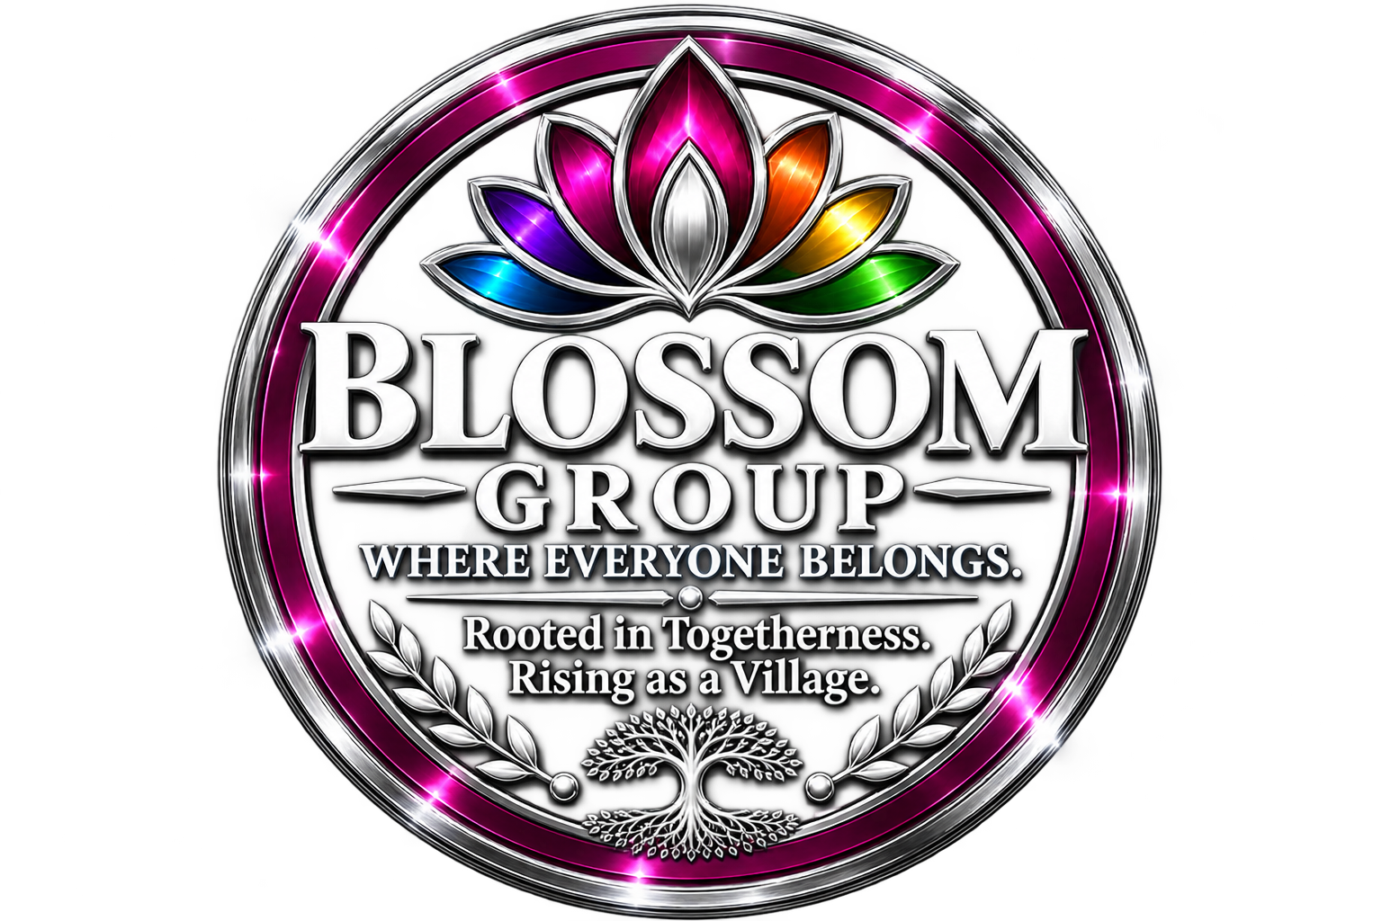
THE BLOSSOM GROUP ASA CIC
Where Everyone Belongs
Rooted in Togetherness. Rising as a Village.
Volunteer Application Form — for Changemakers & Kind Colleagues
volunteers@blossom.place | [Telephone number]
CONFIDENTIAL • GDPR COMPLIANT
Please complete every section of this form in black ink or by typing. If a section is not applicable, please write ‘N/A’ rather than leaving it blank. Completed forms should be returned to volunteers@blossom.place or by post to The Blossom Group ASA CIC, [Address]. The information you provide will be handled in accordance with the UK GDPR and the Data Protection Act 2018, and will be seen only by those members of our team whose role requires access to it.
This form should be read alongside our Volunteers Handbook. If you have not yet received a copy, please contact volunteers@blossom.place before completing the declaration in Section 15.
SECTION 1 — PERSONAL DETAILS
Title | First name(s) | Surname
Preferred name (if different) | Date of birth | Age
Home address (including postcode)

Telephone (home) | Telephone (mobile) | Email address
National Insurance number | Nationality
Do you have the right to volunteer / work in the United Kingdom? ☐ Yes ☐ No

Position applied for | How did you hear about us?
SECTION 2 — LANGUAGES
The communities we serve are wonderfully diverse. Knowing which languages our Changemakers speak helps us match you with people, projects, and events where your language skills can make a real difference. Completion is voluntary.
First / preferred language | Proficiency (native / fluent / conversational / basic)
Other language | Proficiency
Other language | Proficiency
British Sign Language or other signed language (please specify and give proficiency)

Would you be willing to assist with informal translation or interpreting for beneficiaries? ☐ Yes ☐ No ☐ In certain circumstances

Do you require any language support in order to volunteer with us (e.g. easy-read materials, interpreter at induction)?

SECTION 3 — EMERGENCY CONTACT
Full name | Relationship to you
Telephone (day) | Telephone (evening)
Address (if different from yours)

SECTION 4 — VOLUNTEERING PREFERENCES
Areas of interest
Please tick any areas that interest you. You may select as many as you wish.
☐ Community events and outreach
☐ Mentoring and befriending
☐ Administration and office support
☐ Fundraising
☐ Marketing, communications, and social media
☐ Gardening, environment, and grounds
☐ Driving and transport
☐ Translation, interpreting, and language support
☐ Advocacy and community organising
☐ Trustee or governance role
☐ Other (please describe below)
Preferred role / other notes

Why do you want to volunteer with The Blossom Group ASA CIC?
Relevant skills, qualifications, and experience
Please tell us briefly about any skills, qualifications, or experience (paid or unpaid) that you feel would be relevant to your volunteering role.

SECTION 5 — AVAILABILITY
Please tick the sessions during which you would typically be available. This is a guide only, and we will confirm specific times with you following your interview.
 | Monday | Tuesday | Wednesday | Thursday | Friday | Saturday | Sunday
Morning | ☐ | ☐ | ☐ | ☐ | ☐ | ☐ | ☐
Afternoon | ☐ | ☐ | ☐ | ☐ | ☐ | ☐ | ☐
Evening | ☐ | ☐ | ☐ | ☐ | ☐ | ☐ | ☐

Approximate hours per week you can offer | Earliest possible start date
SECTION 6 — BACKGROUND INFORMATION
Are you currently employed? ☐ Yes ☐ No | If yes, employer / occupation
Do you have any medical conditions, disabilities, or additional needs that we should be aware of in order to support you in your volunteering? (This information will be treated in the strictest confidence and will only be used to help us make reasonable adjustments.)

Do you have any unspent criminal convictions, cautions, reprimands, or final warnings under the Rehabilitation of Offenders Act 1974 (Exceptions) Order 1975? ☐ No ☐ Yes — please provide details on a separate sheet in a sealed envelope marked ‘Confidential’.

SECTION 7 — REFERENCES
Please provide the names and contact details of two people who have known you for at least two years and who are not related to you. At least one reference should be from a professional, academic, or voluntary context. We will contact your referees only after you have accepted a volunteer role with us.
Reference 1
Full name | Relationship to you
Organisation (if applicable) | Position / role
Address

Telephone | Email
Reference 2
Full name | Relationship to you
Organisation (if applicable) | Position / role
Address

Telephone | Email

SECTION 8 — DISCLOSURE AND BARRING SERVICE (DBS) CHECK
The Blossom Group ASA CIC is committed to safeguarding and to the protection of the children, young people, and vulnerable adults with whom our Changemakers may come into contact. Depending on the nature of the role for which you are being considered, we may be required to obtain a Disclosure and Barring Service (DBS) check before you commence volunteering with us.
Under our safeguarding policy, the offer of a volunteer role is conditional upon receipt of a satisfactory DBS check where one is required. The cost of the check will be met in full by The Blossom Group ASA CIC. Information disclosed will be handled in strict accordance with the DBS Code of Practice and our Data Protection and Confidentiality Policy.
Having a criminal record will not necessarily prevent you from volunteering with us. Each case is assessed individually, having regard to the nature of the role, the nature and circumstances of any offence, and the length of time that has passed. We ask, however, that you complete the declaration below honestly and in full.
DBS status
Please tick and complete as applicable:
☐ I hold an existing enhanced DBS certificate. Certificate number: __________________________ Issue date: ___________ Registered with DBS Update Service? ☐ Yes ☐ No

☐ I do not hold a current DBS certificate and understand that a new enhanced DBS check will be required.

I consent to The Blossom Group ASA CIC applying for a Disclosure and Barring Service check on my behalf, or to verifying my existing certificate via the DBS Update Service, where the role for which I am being considered requires it. I understand that any offer of a volunteer role is conditional upon receipt of a satisfactory disclosure, and that I am obliged to inform the Organisation of any relevant changes to my status during the period of my volunteering.
Signature | Date | Print name
SECTION 9 — PHOTOGRAPHY AND GDPR CONSENT
From time to time, The Blossom Group ASA CIC takes photographs and video footage at our events and activities, which we may use in our newsletters, on our website, on our social media channels, and in printed publicity materials. Your participation is entirely voluntary and you may change your preferences at any time by writing to volunteers@blossom.place.
Photography and image use
☐ I consent to The Blossom Group ASA CIC taking photographs and video footage in which I appear, and to using these images in printed and online publicity materials as described above.
☐ I do not consent to my image being used. The Organisation will take reasonable steps to ensure that I am not photographed or filmed in identifiable form.
Data protection (UK GDPR)
I understand that The Blossom Group ASA CIC will hold and process the personal data provided in this form (including any special category data, such as information about my health or ethnicity) for the following purposes: assessing my volunteer application; administering my volunteer role if I am accepted; complying with safeguarding, health and safety, insurance, and other legal obligations; and keeping in touch with me about matters directly connected to my volunteering.
I understand that I have the right to access the personal data that the Organisation holds about me, to request its correction or deletion, and to withdraw my consent at any time by contacting volunteers@blossom.place. Full details are set out in the Organisation’s Privacy Notice, which is available on request.
☐ I consent to The Blossom Group ASA CIC holding and processing my personal data as described above.
SECTION 10 — EQUALITY AND DIVERSITY MONITORING (OPTIONAL)
The Blossom Group ASA CIC is committed to equal opportunities and to promoting a diverse and inclusive volunteering community — because at The Blossom Group, everyone belongs. The information in this section is separated from your application on receipt and used only for monitoring purposes. Completion is entirely voluntary and will not affect your application in any way.
Sex | Gender identity (if different) | Age band
Ethnicity | Religion or belief
Sexual orientation | Disability (please describe if you wish)

SECTION 11 — OUR ETHOS, VALUES AND MISSION
The following pages set out the values, principles, and commitments that we ask every Changemaker and Kind Colleague to embrace. They are drawn directly from our Volunteers Handbook. Please read them carefully. Your signature at Section 15 confirms that you have read and agree to be guided by them in all of your work with The Blossom Group ASA CIC.
Our vision
We envision a world where all people thrive and pursue lives of purpose and where every sector of society is just, fair, and inclusive, enabling all people to participate and reach their full potential. We strive for a healthy and prosperous society that promotes all people having equitable access and opportunity.
Our mission
To enable each and every single person to participate actively in society. We do this by equipping everyone with the knowledge, skills, and confidence to make a positive difference to the society in which they live — locally, nationally, and globally.
The BLOSSOM values
Everything we do is guided by six organising values, which together form our simple solution for the communities we serve:
BLOSSOM: The Simple Solution
Safety — Integrated into every aspect of our operations.
Inclusion — We welcome and value diversity with respect, equality, dignity, and acceptance.
Motivation — We inspire and motivate for positive social change.
Positivity — We cultivate a positive environment that boosts happiness, productivity, kindness, and creativity.
Loyalty — We foster a culture of loyalty and support for all, creating pride and passion.
Equity — We provide an equitable environment where every individual can blossom.
The Happy Place
Everything we do is about building ‘happy places’ that contribute to creating a happy and positive environment for everyone. As a Changemaker, you help us bring the following six qualities to every space we occupy:
Our Happy Place principles
Compassion — Embracing empathy and understanding for others and working to create a positive impact on their lives.
Gratitude — Appreciating what is good in one’s life and expressing thankfulness for it.
Kindness — Being considerate and respectful towards others, and spreading positivity and joy.
Inclusiveness — Celebrating diversity and promoting an inclusive environment for all individuals.
Joy — Fostering a sense of happiness and positivity in the environment.
Resilience — The ability to bounce back from challenges and maintain a positive outlook.

☐ I have read the vision, mission, BLOSSOM values, and Happy Place principles set out above, and I agree to be guided by them in my work as a Changemaker with The Blossom Group ASA CIC.

SECTION 12 — VOLUNTEER AGREEMENT
This Agreement describes the arrangement between The Blossom Group ASA CIC (‘the Organisation’) and you (‘the Volunteer’, ‘Changemaker’, or ‘Kind Colleague’). It is binding in honour only, is not a contract of employment, and may be cancelled at any time at the discretion of either party. Nothing in this Agreement is intended to create an employment relationship or any legal obligation between the parties.
The Organisation will:
• Provide a full induction and any training that is reasonably necessary for you to carry out your role.
• Explain the standards we expect of our Changemakers and encourage and support you to reach and maintain them.
• Provide a named supervisor who will meet with you regularly to discuss your role and to offer support.
• Reimburse reasonable, pre-agreed out-of-pocket expenses on production of receipts, in accordance with our Volunteer Expenses Policy.
• Provide insurance cover for you whilst you are undertaking approved activities on our behalf.
• Support your wellbeing across the six elements set out in our Handbook — physical, emotional, social, spiritual, intellectual, and environmental — and provide access to appropriate resources including breaks, wellness support, and mental health signposting.
• Provide opportunities for training and development, including workshops, webinars, and on-the-job learning in areas such as cultural competency, community organising, advocacy, and leadership.
• Consult you on matters that directly affect you and your role.
• Handle any concerns or complaints promptly, fairly, and in accordance with our published procedures.
The Volunteer agrees to:
• Perform the volunteer role to the best of their ability, in a spirit of positivity, kindness, and collaboration.
• Follow the Organisation’s policies, procedures, Code of Conduct, and the guidance set out in the Volunteers Handbook.
• Uphold the BLOSSOM values and the Happy Place principles in all interactions with beneficiaries, colleagues, and members of the public.
• Maintain the confidential nature of any information to which they have access as a Changemaker.
• Meet time commitments and give reasonable notice if they are unable to attend or wish to withdraw from the role.
• Provide references, and to submit to a DBS check where required, before commencing the role.
• Engage with induction, training, and supervision opportunities offered by the Organisation.
• Uphold the good name and reputation of The Blossom Group ASA CIC at all times.

SECTION 13 — CODE OF CONDUCT — OUR SIX PRINCIPLES
All Changemakers at The Blossom Group ASA CIC are expected to follow our Code of Conduct, which is built around six principles set out in the Volunteers Handbook. Beneath each principle you will find the specific expectations that flow from it. Breach of the Code may result in withdrawal of the volunteering opportunity.
1. Respect for All
Treat everyone with kindness, empathy, and respect, regardless of their differences. Bullying, harassment, and discrimination are not tolerated.
- I will treat all beneficiaries, Changemakers, staff, trustees, partners, and members of the public with dignity, courtesy, and respect at all times, and I will not discriminate on the grounds of age, disability, gender reassignment, marriage or civil partnership, pregnancy or maternity, race, religion or belief, sex, or sexual orientation.
- I will actively contribute to an inclusive environment in which everyone belongs, in keeping with the Organisation’s commitment to equity.
2. Keep it Confidential
Protect sensitive information about The Blossom Group ASA CIC, its beneficiaries, staff, and partners.
- I will keep confidential all personal, sensitive, or commercially confidential information that I obtain in the course of my volunteering, and I will not disclose such information to any third party without proper authorisation, save where I am legally required to do so.
- I will comply with all applicable data protection legislation, including the UK GDPR and the Data Protection Act 2018, when handling personal data on behalf of the Organisation.
- I will not post, publish, or share any content on social media or in any public forum that identifies beneficiaries, that reveals confidential information, or that could reasonably bring The Blossom Group ASA CIC into disrepute.
3. Professionalism with Personality
Always behave professionally, but bring your unique personality to the role. Be punctual, reliable, and appropriately presented.
- I will arrive on time for agreed sessions, and I will give reasonable notice if I am unable to attend.
- I will dress appropriately for the role and setting in which I am volunteering, in a way that makes me feel comfortable, confident, and ready to represent the Organisation well.
- I will not use the name, logo, resources, premises, equipment, or reputation of The Blossom Group ASA CIC for personal, political, commercial, or campaigning purposes, or in any way that has not been authorised in advance.
4. Safety First
Prioritise your own safety and the safety of others. Follow safety procedures, report concerns, and seek help when needed.
- I will safeguard the welfare of children, young people, and vulnerable adults, and I will report any safeguarding concerns without delay to the Designated Safeguarding Lead in accordance with the Organisation’s Safeguarding Policy.
- I will comply with all reasonable health and safety instructions, will report accidents, near misses, and hazards promptly, and will not undertake any task for which I have not received appropriate training.
- I will not attend any volunteering activity while under the influence of alcohol or unprescribed drugs, and I will not smoke or vape on the Organisation’s premises or during its activities.
- I will maintain appropriate professional boundaries with beneficiaries at all times, and I will not enter into private arrangements, financial dealings, or personal relationships that could compromise, or be perceived to compromise, those boundaries.
5. Ethical Avengers
Act with integrity and uphold ethical principles in all dealings. Avoid conflicts of interest and stay true to our values and mission.
- I will act honestly, transparently, and in the best interests of the Organisation and the communities we serve.
- I will declare any actual or potential conflict of interest — including any personal, family, financial, or business interest that might conflict with the interests of The Blossom Group ASA CIC — to my supervisor as soon as I become aware of it.
- I will not accept gifts, hospitality, or other personal benefits from beneficiaries or suppliers, save for items of nominal value, and will declare any such offers to my supervisor.
- I understand that the Organisation operates a zero-tolerance approach to bullying, harassment, discrimination, violence, theft, fraud, and abuse of any kind, and that any such behaviour will result in immediate termination of the volunteer arrangement and, where appropriate, referral to the police or other authorities.
6. Team Players
Work together with others and support your colleagues to achieve common goals. Sharing is caring.
- I will attend induction, mandatory training, and supervision meetings as required, and I will contribute constructively to team discussions and decisions.
- I will support fellow Changemakers, share knowledge generously, and ask for help when I need it.
- I understand that my volunteer role does not constitute a contract of employment, that I am not entitled to remuneration, and that either party may end the arrangement at any time by giving reasonable notice.

SECTION 14 — ONBOARDING AND YOUR FIRST DAY
We want your first day to be stress-free and enjoyable. The following expectations are taken from the ‘On Your First Day’ section of our Volunteers Handbook. Please read them, tick each box to confirm that you understand, and raise any questions with your Volunteer Coordinator before you start.
☐ Arrival time — I understand that I should arrive at the office (or agreed venue) 15 minutes before my scheduled start time, so that I can get settled and ready.
☐ Dress code — I understand that I should dress in a way that makes me feel happy, confident, and appropriately presented for the role I am undertaking.
☐ Paperwork — I understand that I should bring a form of identification and any additional paperwork that has been requested prior to my first day.
☐ Orientation — I understand that I will take part in an orientation covering the Organisation’s history, mission, values, and policies, together with a tour of the premises and introductions to the team.
☐ Equipment and schedule — I understand that I will be provided with any equipment necessary to carry out my role, and with a detailed schedule for my first week, including training and meetings.
☐ Wellbeing — I understand that the Organisation supports my wellbeing across the six elements of physical, emotional, social, spiritual, intellectual, and environmental health, and that I am encouraged to take breaks when needed and to prioritise self-care.
☐ Support — I understand that I am not expected to know everything on day one, and that the Organisation is committed to supporting me every step of the way.
SECTION 15 — HANDBOOK ACKNOWLEDGMENT, DECLARATION AND SIGNATURE
By signing below I confirm that:
(a) the information I have provided in this form is true, accurate, and complete to the best of my knowledge and belief;
(b) I have received a copy of the Volunteers Handbook of The Blossom Group ASA CIC, have read it, and have had the opportunity to ask questions about anything I did not understand;
(c) I have read, understood, and agree to abide by the Volunteer Agreement (Section 12), the six-principle Code of Conduct (Section 13), the onboarding expectations (Section 14), and the vision, mission, BLOSSOM values, and Happy Place principles set out in Section 11;
(d) I consent to The Blossom Group ASA CIC holding and processing my personal data for the purposes of considering and, if applicable, administering my volunteer role, in accordance with the Organisation’s Privacy Notice;
(e) I understand that any offer of a role is subject to satisfactory references and, where applicable, a satisfactory DBS check;
(f) I understand that any material misrepresentation or omission may result in the withdrawal of any offer or the immediate termination of my volunteer role; and
(g) I understand that this arrangement is binding in honour only, is not a contract of employment, and may be cancelled at any time at the discretion of either party.

Signature | Date | Print name

For office use only
Date received | Received by | Reference no.
Handbook issued (date) | References requested | References received
DBS submitted (date) | DBS returned (date) | Certificate no.
Interview date | Induction date | Outcome

